EXPERIMENT NO 6

Aim: TO STUDY SUB QUERIES AND NESTED QUERIES IN ORACLE**.**

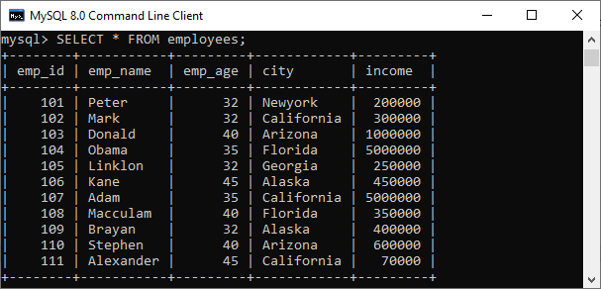

SUBQUERY WITH COMPARISON OPERATOR

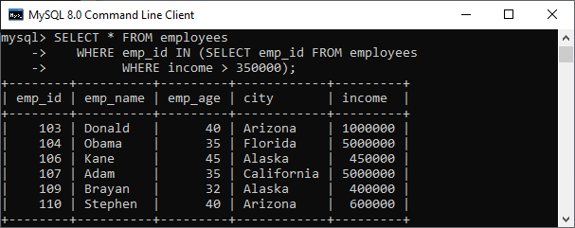

CORRELATED SUBQUERIES

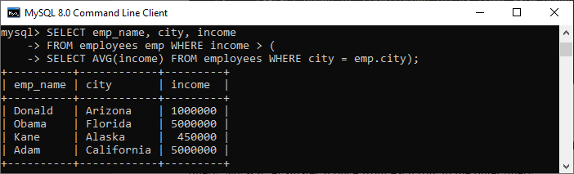

SUBQUERY IN FROM CLAUSE

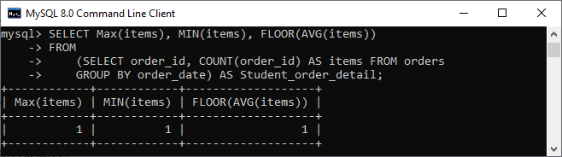

Question:

